|  |
| --- |
| letöltés.png |
| **Infopack** |
| **EVS in Debrecen - the project of “Future Kindergartens of Europe 2”** |
|  |



**Introduction**

**Please, find the basic information about the working environment below:**

**The 6 volunteers we host will be placed in 3 traditional kindergartens; two volunteers per kindergarten but each one of them in separate groups. The children they will work with are all between 4 or 5 years old. Each group has two –classically female- teachers and at least one nurse. Under a professional guidance, volunteers will contribute to day-to-day activities of their kindergarten including participation in preparation for meals or for going to the yard to play and other fun activities according to volunteers’ skills and interests always using non-formal education. In a limited way, they will have the possibility to run mini workshops depending on the capacity of each kindergarten. In addition, the volunteers’ tasks will be in line with the activities of Világjáró Önkéntes.**

**During the project, we will touch problems or challenges such as gaining new skills, developing existing ones and having work experience and self-knowledge. The solution for these obstacles will later count as a great value to the volunteer's competitiveness in the labor market.**

**The hosting kindergartens will involve the volunteer in the everyday life of the target group with their activities, so continuous and mutual improvement is guaranteed. We organize joint sports, cultural and skill-building activities and events both indoors and outdoors. For information spreading purposes, Világjáró will accompany the volunteers to schools and the university. In these common events, volunteers are going to be able to make and implement independent decisions, come up with constructive ideas, manage everyday conflicts, and find positive, constructive solutions to the problems.**

**Number of volunteers: in total 6 from different countries (2 person per kindergarten)**

**Start of EVS in your case: 1 August 2018**

**End of EVS in your case: 31 July 2019**

**Duration: 12 months**

**Place: Debrecen, Hungary**

**Hosting organization:**

**Százszorszép Óvoda (address: 4031, Debrecen, Széchenyi u. 65.)**

**Görgey Utcai Óvoda (address: 4032, Debrecen, Görgey u. 5-7.)**

**Coordinating Organization: Világjáró Önkéntes Nonprofit Ltd.**

**The location**

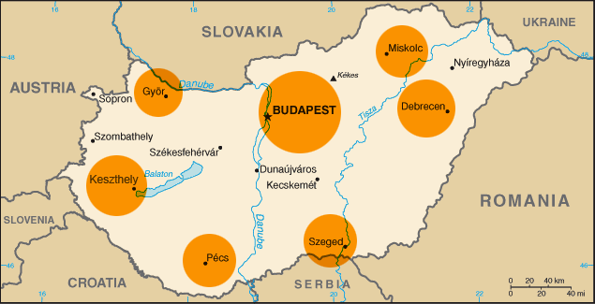**Debrecen is the second largest city in Hungary after Budapest. It is one of the cultural and social centers of Hungary for almost half a century. The presence of several multinationals as well as the university, with a student population of 30 thousand, including thousands of overseas students, gives a cosmopolitan atmosphere to the city. This is further accentuated by international sporting and cultural events. In addition to the internationally renowned annual Debrecen Flower Parade in August 20th, the whole year is packed with cultural and gastronomic events.**

**The main place of work for the EVS volunteers will be one of the aforementioned kindergartens. But the office of Világjáró Önkéntes Organization, which is situated in the building of Lovarda Cultural and Conference Centre, will be the headquarter when it comes to practical details (e.g. arranging staff meetings, forwarding travel tickets needed for the reimbursement, handing out pocket money or monthly food allowance – if it won’t be possible to eat in the kindergarten, etc.)**

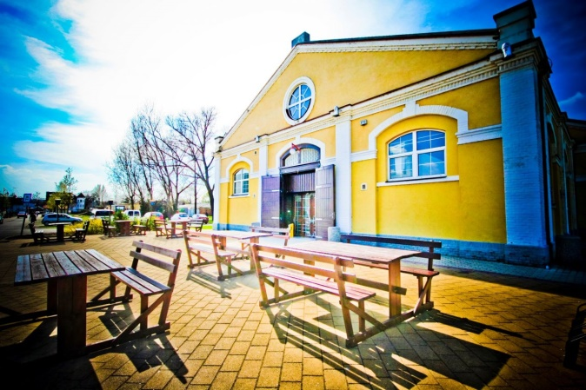

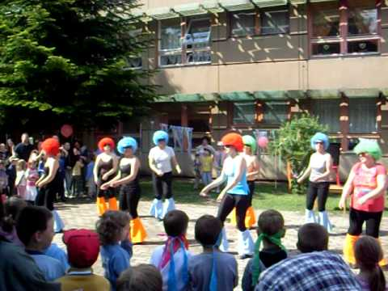**The kindergartens are located close to the city centre and is easily reach from the dormitory where the volunteer will live.**

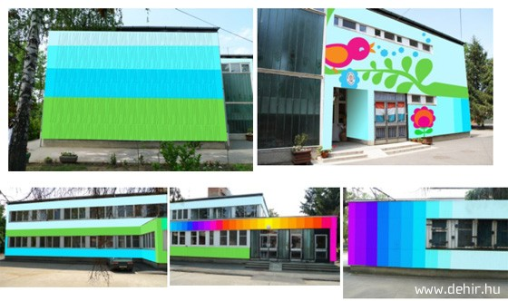

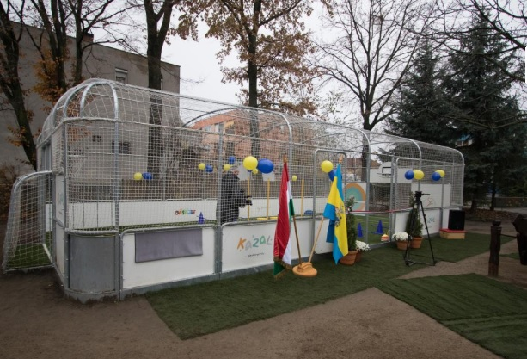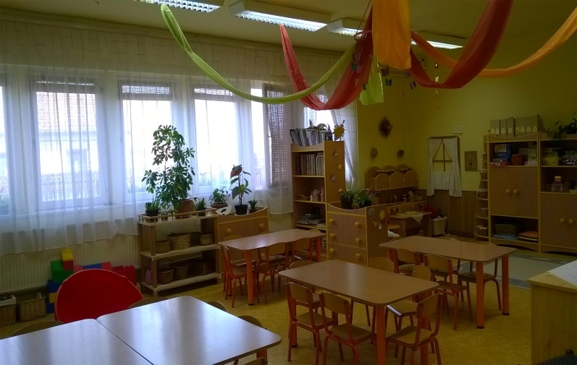**One of the rooms of activity newly opened mini football pitch**

**Main tasks**

|  |  |
| --- | --- |
| **In terms of the kindergartens:** | **In terms of Világjáró Önkéntes Organization:** |
| **- Help with everyday tasks and routines**  **- Promotional work**  **- Raising the importance of environmental awareness, healthy lifestyle and common values**  **- Participate in organizing the indoor and outdoor programs (trips, national celebrations, performances)**  **- Handicrafts**  **- Play with the children and keep an eye on them**  **- Run mini workshops in foreign literature and arts topics** | **- Weekly meeting with mentors**  **- Running a blog about experiences**  **- Promotion of Erasmus + and EVS in schools and university**  **- Developing your own ideas and preparing for events and activities based on them**  **- Hungarian language class twice a week**  **- Weekly orientation meetings with the coordinators of Világjáró Önkéntes** |

**This is an example of your weekly schedule, which may vary due to the different profiles of kindergartens:**

**Accomodation**

**The volunteers will live in shared rooms with 2 separate beds in 2 different university dormitories with other local and international students. Internet connection, common kitchen, washing machine and common showers are also available. Világjáró arranges the accommodation that are situated about 25 minutes from the city center with public transport. The dormitories will provide bed sheets, pillows and blankets. They will also have an iron and ironing table, and can provide foldable metal clothes dryer.**

**You can expect a dorm room like this (surely without the bags):**

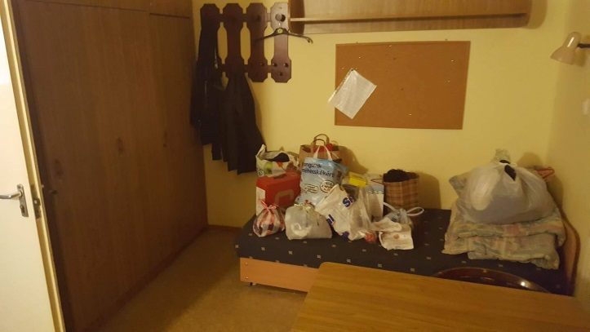

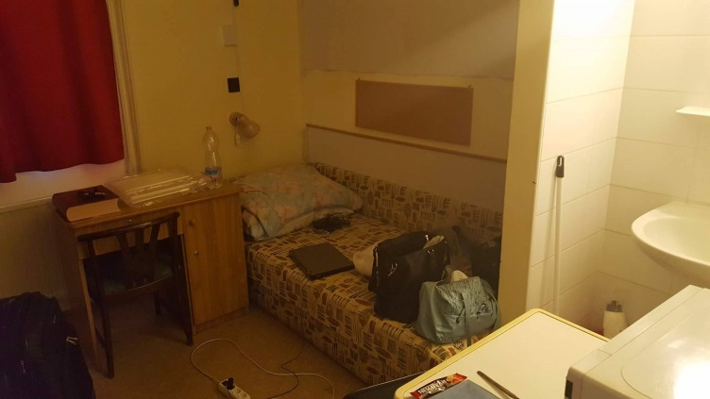

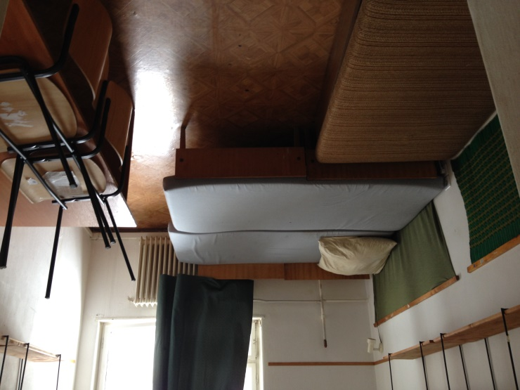**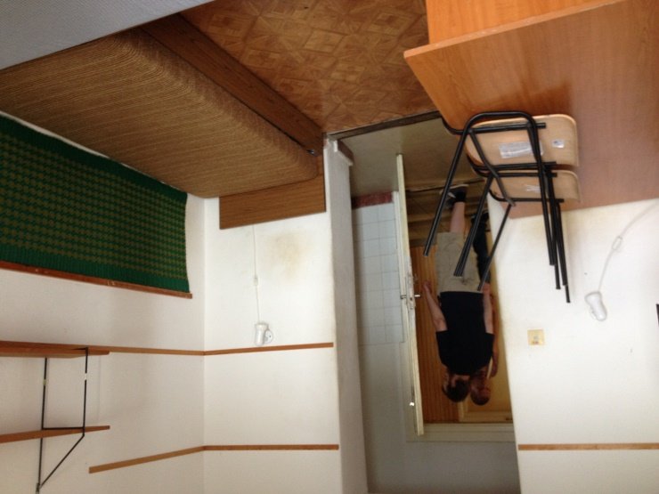Or like this:**

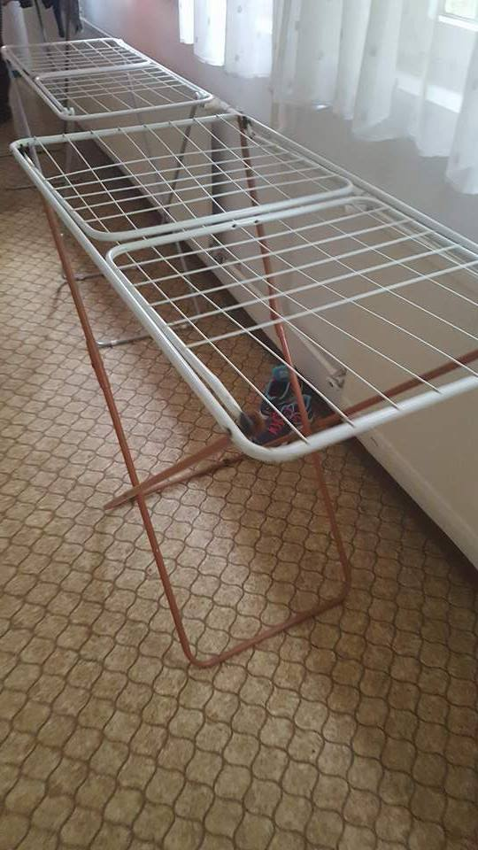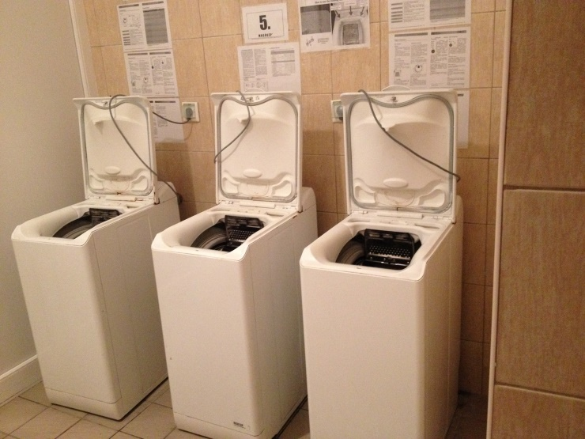

**Moreover, common toilets and showers are like these:**

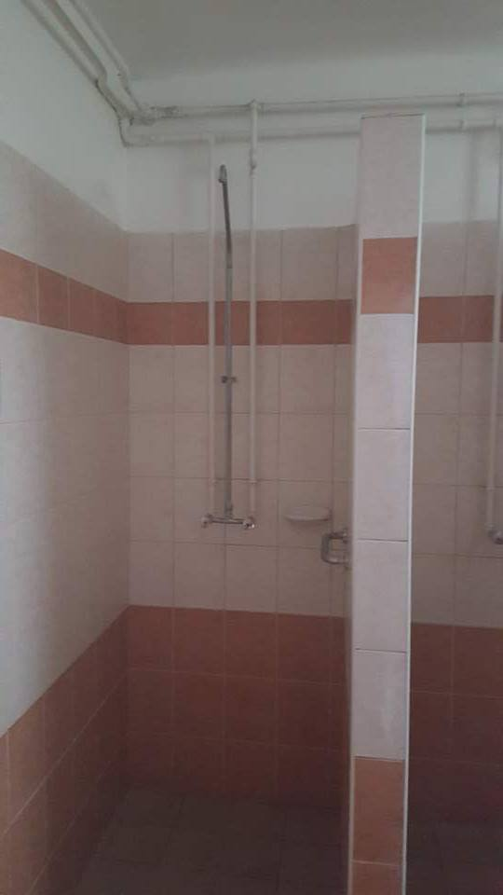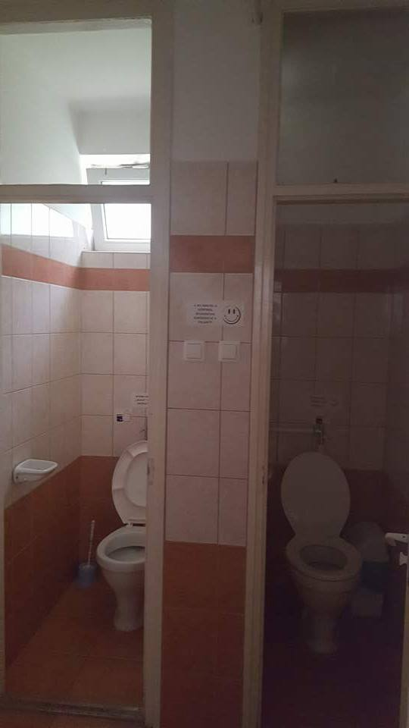

**Common kitchen with all electric equipment (bowls, cutleries, glasses or mugs are not included but provided by us) and a dryer will be available:**

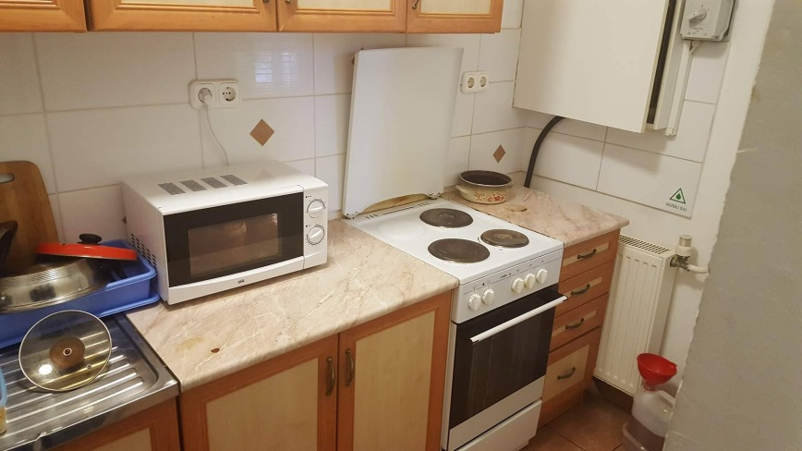

**Health and Insurance**

**Insurance will cover the Volunteers for the entire duration of the project (CIGNA). The insurance cover under Erasmus+ is complementary to the coverage provided by the national system and so that it is very recommendable for volunteers to carry the European Health Insurance Card.**

**If you have a health problem and once you ask for the receipt for buying the medicine or a medical treatment and send to CIGNA Health Insurance Company, the reimbursement procedure by will be undertaken.**

**Financial support and Transport**

**Pocket money of 120 euro per month will be provided for each volunteer plus a monthly ticket for public transport.**

**Volunteers will organize the food themselves according to their own preferences for the weekends (for that purpose the hosting organization will provide a lump sum of money). During weekdays, they get warm food and beverage in the kindergarten or in a restaurant by having prepaid menu tickets.**

**The volunteers’ travel budget from and to the homecountry will be defined by the European Commission Distance Calculator. We will surely reimburse the travel expenses accordingly at halfway of your service.**

**We will also provide a Hungarian language course for the volunteers twice a week.**

**Useful information**

1. **How to get from Budapest airport to Debrecen** 
   1. **From Budapest airport to Ferihegy train station**

**Right after you arrive to Budapest Airport don’t forget to change your money into HUF.**

**Here you can find the  exchange boxes:**

<http://www.bud.hu/english/passengers/shopping_and_gastronomy/services/interchange-8182.html> **At the arrival side of the airport in the newspaper store named  or when you leave the last automatic door to your right you will see a booth with a logo of the Budapest public transport Company (below in the photo):**

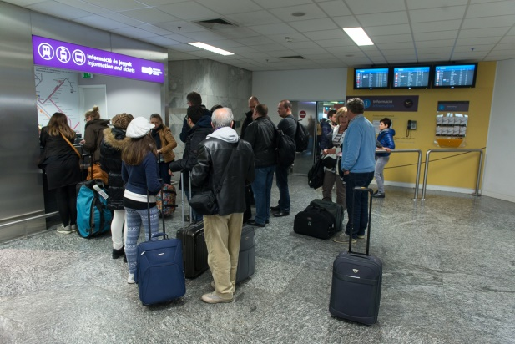 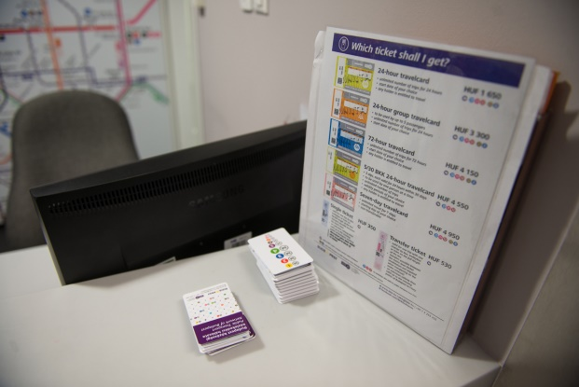

**There, you can buy a ticket for the bus. The single ticket costs 350 Forint. You can also buy it outside in the bus stop from a ticket machine (but it is usually too crowded), or from the driver (in this case it is more expensive; 450 Forint).**

**You will need to take the bus number 200E which commutes really frequently. The bus stop is in front of the Airport building (to the right hand).**

**You will get off at Ferihegy vasútállomás (the 4th stop). Here is the interactive map of the airport building:**

<http://bud.hu/english/passengers/before_flight/interactive_map>

**When you get off the bus you will see the following view:**

<https://www.google.hu/maps/@47.437882,19.22325,3a,75y,201.7h,85.88t/data=!3m4!1e1!3m2!1sHiCcq-LVPewQ8KL7Xz1CFg!2e0>

**There are a double tube-like stairs. You go up the stairs and all the way to its end. When you get down turning to the left, from the outside of the tube there is a very small ticket office. In case it is closed, you can find a ticket machine on the platform.**

* 1. **From Ferihegy train station to Debrecen train station**

**Buy a one-way ticket for an Intercity (IC) train (it is faster, safer and more comfortable than the others) to Debrecen. Generally it is a 2,5 hours travel. The ticket is available from around 4.315 HUF in 2nd class.**

**The IC train leaves in every hour.**

**The timetable of the train to Debrecen is here:**

[**http://elvira.mav-start.hu/elvira.dll/uf**](http://elvira.mav-start.hu/elvira.dll/uf)

[**http://www.mav-start.hu/english/index.php**](http://www.mav-start.hu/english/index.php)

1. **Weather in Hungary**

**The climate of Hungary can be described as a typical European continental-influenced climate with warm, dry summers and cold and chilly winters. January is the coldest month with daytime temperatures usually around zero, but in some cases months in winter time can be very cold with temperatures far below zero.**

**In summer, the average daytime temperature reaches 28-30°C, but sometimes quite higher, 33°C or even more. In most of the time, there is dry weather with sunny spells, although sometimes heavy thunderstorms which can occur at the end of the day. July is the warmest month with an average temperature of 32°C.**

**Generally, the best weather is in May-September, when days are warm and the nights are cool, although it rains more in spring than in summer.**

1. **What to bring**

* **Towels and flip-flops for the common shower**
* **Some warm clothes as autumn and winter here can be chilly and after freezing**
* **Hair-dryer (hair straightener)**
* **Power adapter (in Hungary the power sockets are of type C and F. The standard voltage is 230 V and the standard frequency is 50 Hz.)**
* **Any type of spices/ingredients that you use in everyday cooking and are specific to your country**
* **Swimsuit if you want to try our thermal baths.**

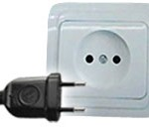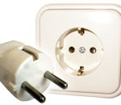

**Type C Type F**